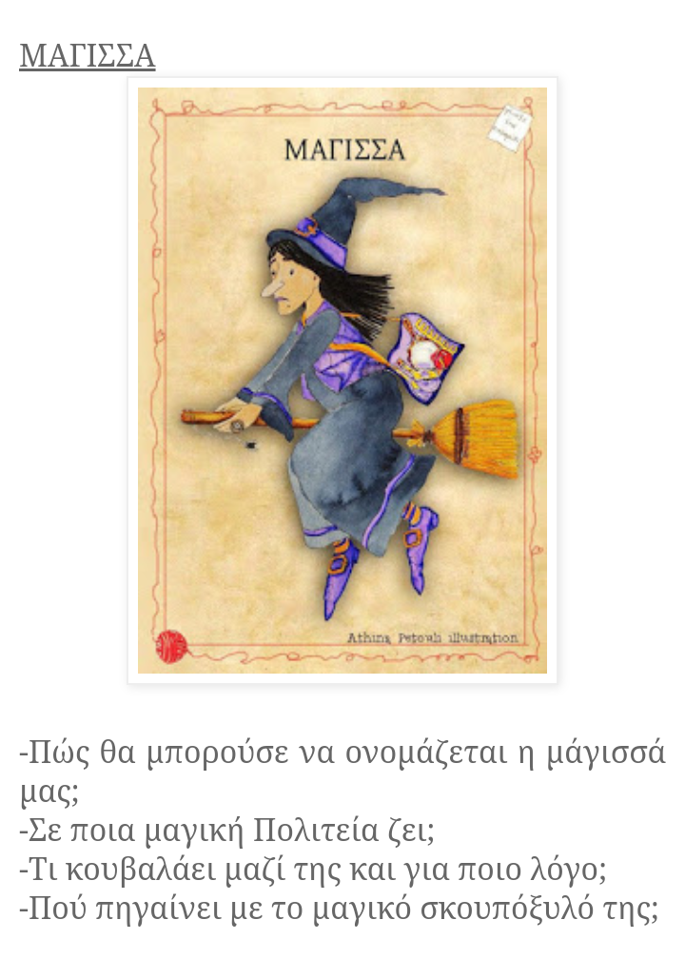
ΕΛΛΗΝΙΚΑ Ε΄: Δημιουργήστε δύο ξεχωριστές ιστορίες χρησιμοποιώντας την κάθε εικόνα και τα ερωτήματά που τη συνοδεύουν. Φροντίστε να βάλετε όλη σας τη φαντασία!!!!

Κάποτε………………………………………………………………………………………………………………………………………………………………………………………………………………………………………………………………………………………………………………………………………………………………………………………………………………………………………………………………………………………………………………………………………………………………………………………………………………………………………………………………………………………………………………………………………………………………………………………………………………………………………………………………………………………………………………………………………………………………………………………………………………………………………………………………………………………………………………………………………………………………………………………………………………………………………………………………………………………………………………………………………………………………………………………………………………………………………………………………………………………………………………………………………………………………………………………………………………………………………………………………………………………………………………………………………………………………………………………………………………………………………………………………………………………………………………………………………………………………………………………………………………………………………………………………………………………………………………………………………………………………………………………………………………………………………………………………………………………………………………………………………………………………………………………………………………………………………………………………………………………………………………………………………………………………………………………………………………………………………………………………………………………………………………………………………………………………………………………………………………………………………………………………………………………………………………………………………………………………………………………………………………………………………………………………………………………………………………………………………………………………………………………………………………………………………………………………………………………………………………………………………………………………………………………………………………………………………………………………………………………………………………………………………………………………………………………………………………………………………………………………………………………………………

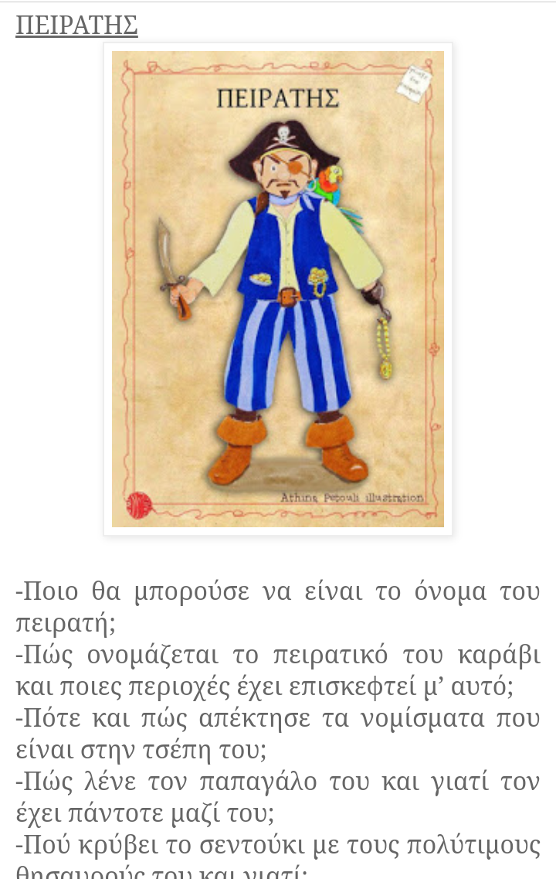

Ζούσε κάποτε………………………………………………………………………………………………………………… ………………………………………………………………………………………………………………………………………………………………………………………………………………………………………………………………………………………………………………………………………………………………………………………………………………………………………………………………………………………………………………………………………………………………………………………………………………………………………………………………………………………………………………………………………………………………………………………………………………………………………………………………………………………………………………………………………………………………………………………………………………………………………………………………………………………………………………………………………………………………………………………………………………………………………………………………………………………………………………………………………………………………………………………………………………………………………………………………………………………………………………………………………………………………………………………………………………………………………………………………………………………………………………………………………………………………………………………………………………………………………………………………………………………………………………………………………………………………………………………………………………………………………………………………………………………………………………………………………………………………………………………………………………………………………………………………………………………………………………………………………………………………………………………………………………………………………………………………………………………………………………………………………………………………………………………………………………………………………………………………………………………………………………………………………………………………………………………………………………………………………………………………………………………………………………………………………………………………………………………………………………………………………………………………………………………………………………………………………………………………………………………………………………………………………………………………………………………………………………………………………………………………………………………………………………………………………………………………………………………………………………………………………………………………………………………………………………………………………………………………………………………………………………………………

ΟΝΟΜΑ ΜΑΘΗΤΗ/ΤΡΙΑΣ: ………………………………………………………………………………………………………….

