*Γιατί έμεινες μόνη σου;
*Τι έκανες
στο δωμάτιό σου;
*Τι άλλο;
*Πώς ένιωσες;
*Πότε ήρθαν οι γονείς σου;

Αυτά θα βοηθήσουν!
Παρατήρησε καλά την εικόνα και βάλε τον εαυτό σου στη θέση του παιδιού.
ΜΟΝΗ ΜΟΥ ΣΤΟ ΔΩΜΑΤΙΟ
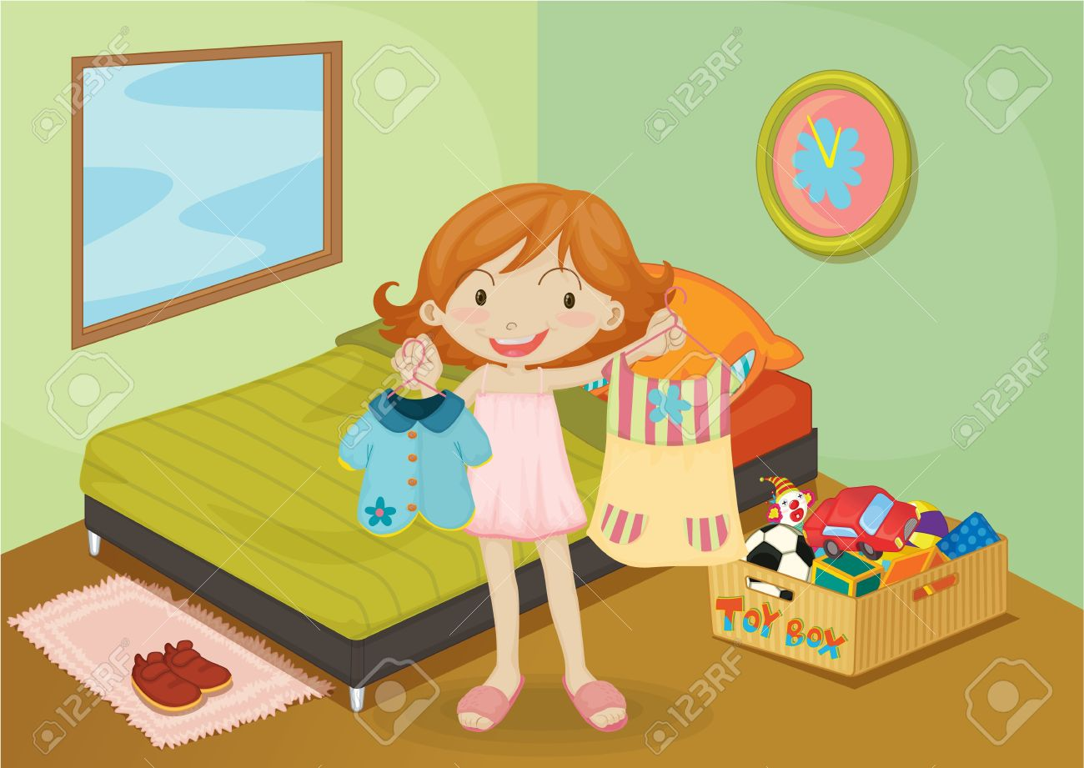

_________________________________________________________________________________________________________________________________________________________________________________________________________________________________________________________________________________________________________________________________________________________________________________________________________________________________________________________________________________________________________________________________________________________________________________________________________________________________________________________________________________________________________________________________________________________________________________________________________________________________________________________________________________________________________________________________________________________________________________________________________________________________________________________________________________________________________________________________________________
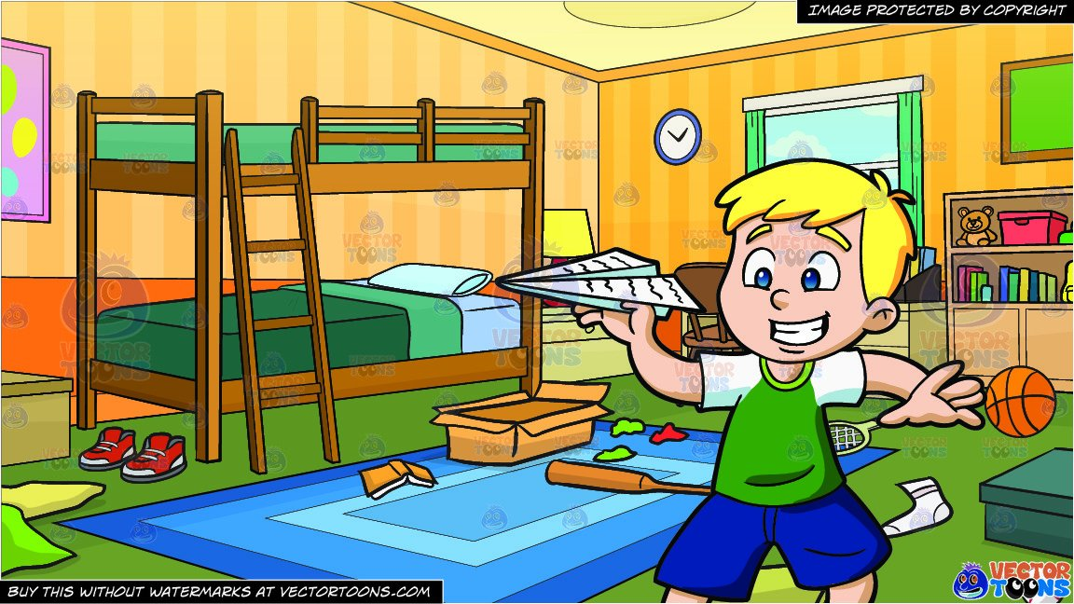
*Γιατί έμεινες μόνος σου;
*Τι έκανες
στο δωμάτιό σου;
*Τι άλλο;
*Πώς ένιωσες;
*Πότε ήρθαν οι γονείς σου;

Αυτά θα βοηθήσουν!
ΜΟΝΟΣ ΜΟΥ ΣΤΟ ΔΩΜΑΤΙΟ
Παρατήρησε καλά την εικόνα και βάλε τον εαυτό σου στη θέση του παιδιού.

_________________________________________________________________________________________________________________________________________________________________________________________________________________________________________________________________________________________________________________________________________________________________________________________________________________________________________________________________________________________________________________________________________________________________________________________________________________________________________________________________________________________________________________________________________________________________________________________________________________________________________________________________________________________________________________________________________________________________________________________________________________________________________________________________________________________________________________________________________________

